Body  Reshaping  Checklist  This multiple choice checklist should be completed to help determine which program (free or paid) is right for you. Avoid beginning a program without finishing this first, as it helps determine direction. You should know what you want your final body to look like before you begin making changes.  The first available answer choice to each inquiry is there on purpose! It yields the most masculine appearance, with second option yielding the next closest masculine appearance. This is a fool-proof questionnaire. If you don’t know what you are doing or what you want, you should select the first option to every question.  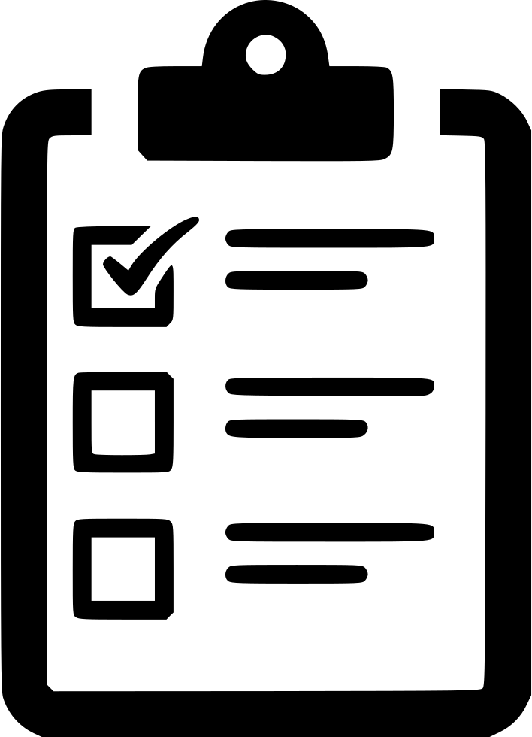 |   http://www.sofffft.com/men  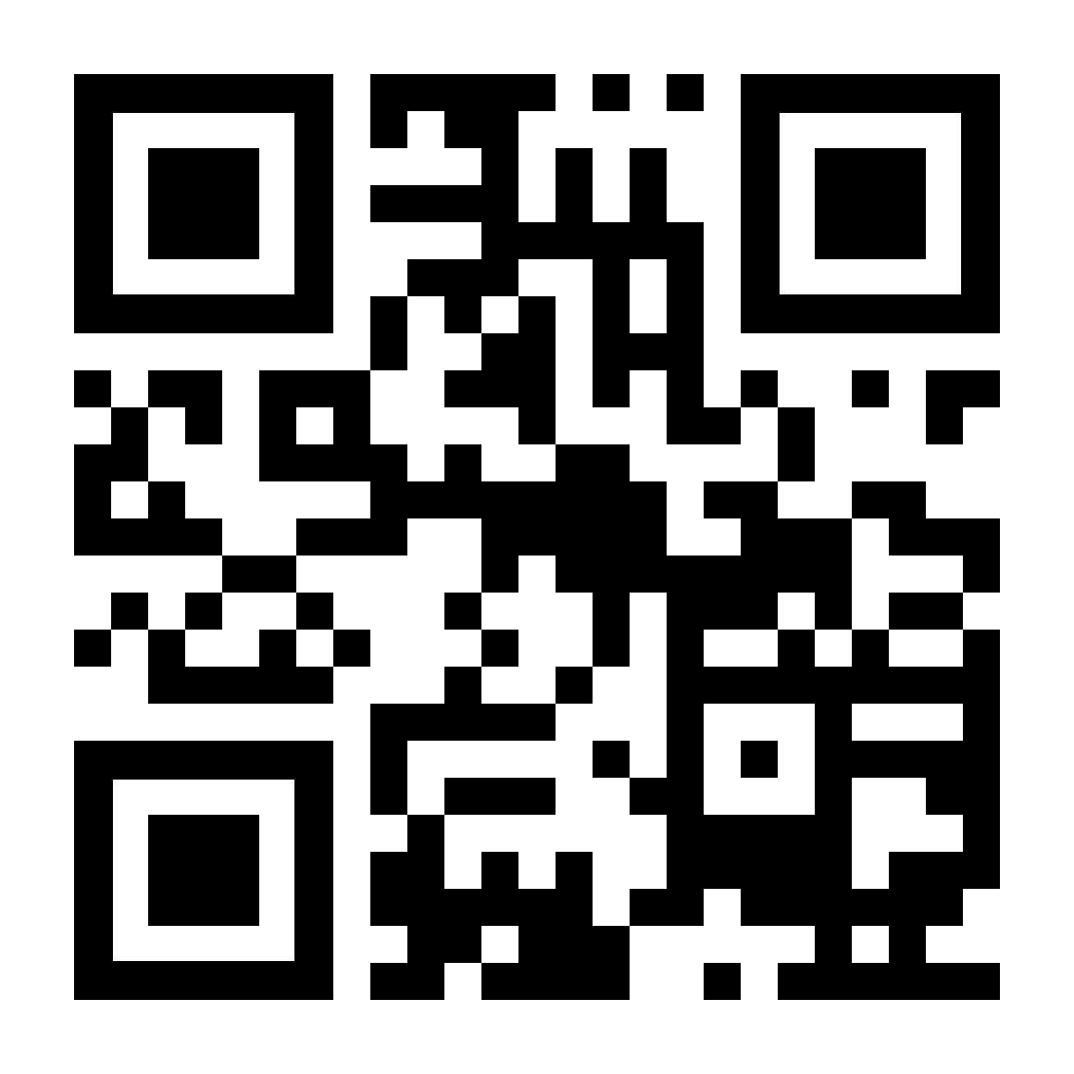
Thigh size: (medium) (small) (large)
Thigh composition: (fat/muscle) (muscle) (fat)
Bicep size: (medium) (large) (fat)
Bicep composition: (fat/muscle) (muscle) (fat)
Belly: (6-pack abs) (8-pack abs) (flat)
Waist: (straight line) (contoured in) (hourglass)
Forearm size: (medium) (large) (small)
Chest size: (medium) (large) (small)
Calf composition: (fat/muscle) (muscle) (fat)
Chest composition: (soft firm) (hard firm) (soft not firm)
Thigh gap: (slight gap) (no gap)
Butt: (medium) (large) (small)
Butt composition: (soft firm) (hard firm) (soft not firm)
Trapezius size: (triangle) (slight rise) (no rise)
Neck size: (medium) (large) (small)
Cheek bones: (visible) (smooth with cheeks) (sticking out)
Shoulders: (medium size ball) (large size ball)
Hands: (muscle between index and thumb) (V between index and thumb)
Arms: (medium biceps/triceps) (straight stick) (large biceps/triceps)
Legs: (mild contour) (slight contour) (straight stick)
Penis: (contoured base) (L-shaped base) (Triangle-shaped base)
Bone visibility: (not visible) (visible)
Eye size: (medium) (small) (larger)
Skin tan: (slight tan) (no tan) (dark tan)
Balance: (excellent) (good) (fair)
Teeth whiteness: (white) (extra white) (moderately white)
Skin complexion: (smooth) (some imperfections)
Sex appeal: (high) (medium) (unconcerned)
Penis hardness: (hard) (medium hard) (unconcerned)
Walking stride: (medium) (short) (long)
Attractiveness: (high) (medium) (unconcerned)
Silhouette: (curved) (straight) (unconcerned)
Tallness: (tall) (somewhat tall) (shorter)
Body strength: (decent strength) (high strength) (mild strength)
Posture: (vertical, shoulder back) (vertical) (improved)
Arm sway: (confident appearance) (no change)
Walking appearance: (confident walk) (no change)
Ending flexibility: (moderate) (low) (high)
Method preferred: (active lifestyle) (excessive exercise) (no exercise)
Achievement time-frame: (long) (medium) (short)
Eye glasses: (no eyeglasses needed) (I don’t want eyeglasses/contacts anymore) (indifferent)
Collarbones: (not visible) (visible)
Hipbones: (not visible) (visible)
Appearance: (medium and strong) (small and slim) (large and strong)
Fitness perception: (fit with gym time) (born sexy) (fit without gym time)
New you: (some improvements over my younger self) (like my younger self) (like a whole different person)
Penis size: (large) (medium) (unconcerned)
Look: (classy) (handsome) (blend in)
Favorite clothing season: (Summer) (Spring) (Fall) (Winter)
Cheeks: (flat) (slightly sunken) (slight round)
Particulars: (I want maximum masculinity/handsomeness) (I want to be skinny) (very particular end look)
Ribs: (not visible) (visible) (sticking out)
Forearm shape: (slight contour) (straight stick) (straight into contour)
Upper-arm shape: (bicep/tricep bulges) (straight stick)
Calf shape: (muscle bulge) (slight contour) (straight stick)
Thigh shape: (medium contour) (slight contour) (straight stick)
Desired height: (slight height increase) (significant height increase) (unconcerned)

